

PROJECT REPORT

NAME-DIVY JINDAL

REGISTRATION NUMBER-25BCE10769

SUBJECT-INTRODUCTION TO PROBLEM SOLVING AND PROGRAMING

FACULTY -DR A.V.R. MAYURI

SLOT-A11+A12+A13

INTRODUCTION:

Title: Online Drink Ordering System for TOPRATEEEDDDD! Cafe Language: Python 3 Submitted by: [DIVY JINDAL]

The "Online Drink Order System" is a console-based Python application designed for TOPRATEEEDDD!. It aims to automate the process of ordering beverages by allowing customers to view a menu, select items, calculate their bill, and view a final order summary. This project demonstrates the use of fundamental programming concepts such as variables, dictionaries, loops, conditionals, and list manipulation.
- OBJECTIVE:

1.To create a user-friendly interface for ordering drinks.
2.To replace manual billing with an automated calculation system.
3.To prevent billing errors by using stored price data.
4.To learn and demonstrate Python control structures (While loops, If-Else statements).

. System Requirements
Hardware: Any computer capable of running Python.
Software: Python 3.x Interpreter, any Code Editor (VS Code, PyCharm, IDLE)

3. Code Explanation & Logic:
The program follows a linear logical flow:
1.User Greeting: The user is welcomed and asked for their name.
2.Menu Display: A dictionary (menu) stores the items and their prices. The menu is printed for the user to see.
3.Order Loop: A while loop is in tiated to allow multiple items to be ordered.
The user inputs an item name.
The program checks if the item exists in the menu dictionary.
4.If found: The price is added to order_total, and the item is added to the selected_items list.
5.If not found: An error message is displayed prompting the user to check spelling.
6.Termination: The user can type 'done' or answer 'No' to the "add another item" prompt to finish ordering.
7.Bill Generation: The program iterates through the selected_items list, prints the final receipt, and displays the total amount to pay.
- SOURCE CODE:
print("Welcome to Online Drink Order by TOPRATEEDDDD")
name = input("Please enter your name: ")
print(f"What would you like to Drink, {name}? \n\nHERE IS OUR MENU")

# Menu Dictionary
menu = {
'water melon seasonal': 100,
'pineapple-juice': 100,
'mix-fruite-juice': 120,
'orange-juice': 160,
'cappucchino': 70,
'expresso': 70,
'rose-shake': 100,
'black-current-shake': 100,
'kitkat-shake': 130,
'oreo-milk-shake': 140,
'cold-coffee': 110,
'cold-coffee-with-icecream': 130,
'iced-cold-coffee': 120,
}

# Displaying Menu
print("-" * 30)
for item, price in menu.items():
print(f"{item.title()}: Rs{price}")
print("-" * 30)

order_total = 0
ordering = True
selected_items = []

while ordering:
item = input("\nEnter the name of item you would like to drink (or 'done' to finish): ").lower()

if item == 'done':
ordering = False
continue

if item in menu:
order_total += menu[item]
selected_items.append(item)
print(f"Your item **{item.title()} (Rs{menu[item]})** has been added to your order.")
print(f"Current total is **Rs{order_total}**.")
else:
print(f"Your selected item **{item}** does not exist in our menu. Please check the spelling.")

if ordering:
another_order = input("Do you want to add another item? (Yes/No): ").lower()
if another_order != "yes":
ordering = False

# Final Bill
print("\n" + "="*10 + " ORDER SUMMARY " + "="*10)
print(f"Hello, **{name}**.")
print("You ordered the following items:")

for drink in selected_items:
print(f"- {drink.title()}: Rs{menu[drink]}")

print("-" * 30)
print(f"The Final Total amount to PAY is **Rs{order_total}**.")
print("Thank you for ordering with TOPRATEEEDDDD!")
- CODE INPUT:

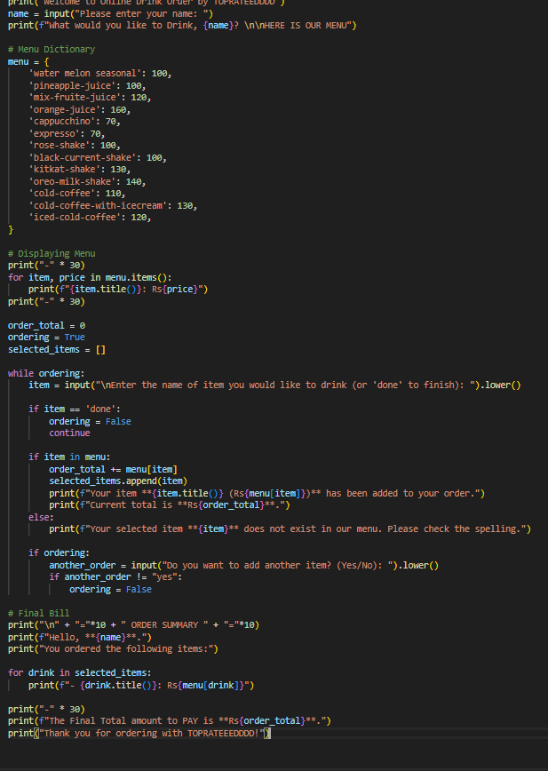

- CODE OUTPUT:

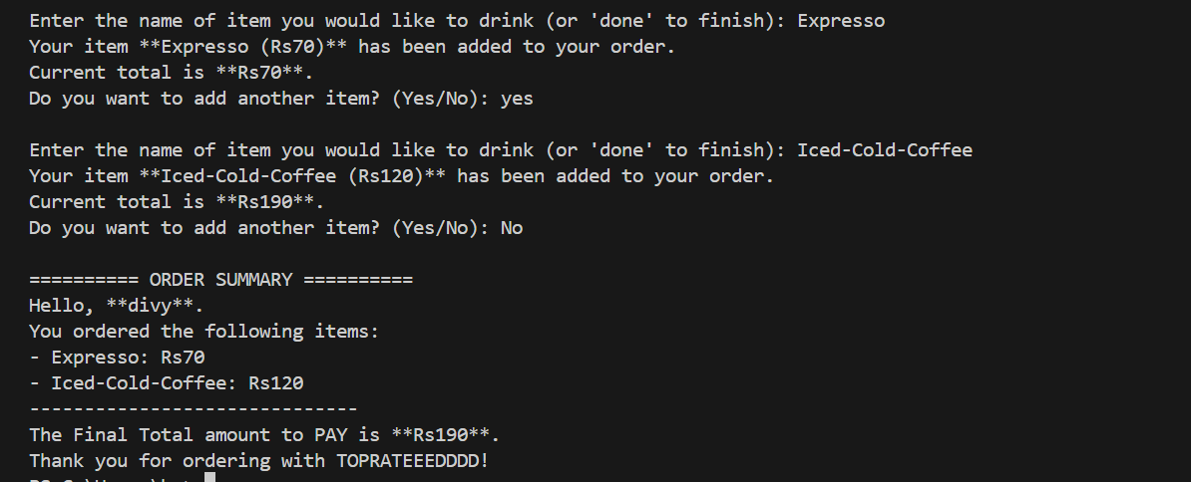
- TEST CASE:
Test Case 1: Valid Order
Input Name: Alice
Selection: cappucchino, kitkat-shake
Expected Output: Total should be 200 (70 + 130).
Result: Success.
Test Case 2: Invalid Item Entry
Input: apple juice (Not in menu)
Expected Output: "Your selected item apple juice does not exist in our menu."
Result: Success.
Test Case 3: Case Sensitivity Handling
Input: COLD-COFFEE (Uppercase input)
Expected Output: System converts input to lower case and accepts

Functional Requirements
These requirements define what the system does specifically based on the provided logic.
User Identification: The system must accept and store the user's name via console input.
Menu Display: The system must display a predefined list of drinks and their corresponding prices to the user.
Order Input: The system must allow the user to input drink names via the console.
Input Validation:
The system must recognize items regardless of case (e.g., "Cappucchino" vs "cappucchino").
The system must validate if the entered item exists in the menu.
If the item is invalid, the system must notify the user without crashing.
Order Calculation:
The system must maintain a running total of the order cost.
The system must maintain a list of selected items.
Flow Control:The system must allow the user to stop ordering by typing 'done' during item selection.The system must prompt the user after every successful addition to see if they want to add another item.
Billing: The system must generate a final order summary displaying the user's name, the list of ordered items, individual prices, and the final total amount.

Non-Functional Requirements
These requirements define how the system performs.
Usability: The interface is a Command Line Interface (CLI) using simple text prompts. It utilizes basic string formatting (Title Case) to make the output readable.
Reliability: The system handles case sensitivity using .lower() to ensure user inputs match menu keys reliably.
Performance: The system is lightweight and operates with immediate response time ($O(1)$ dictionary lookups).
Portability: The script requires a Python 3 runtime environment to execute.
System Architecture
Since this is a script-based application, the architecture is Monolithic and Procedural.
Interface Layer: The Standard Input/Output (Console/Terminal).
Application Logic: The Python interpreter executing the while loop and conditional statements.
Data Layer: In-memory data structures (The menu Dictionary and selected_items List).
Architecture Overview:
User <--> Terminal (I/O) <--> Python Script (Logic & Data)

PROCESS FLOW

This text description outlines the visual flow of the code:
Start
Input: User enters Name.
Display: System prints Menu.
Loop Start:
Input: User enters drink_name.
Decision: Is input == 'done'?
Yes: Go to Final Summary.
No: Continue.
Decision: Is drink_name in Menu?
No: Print "Item does not exist." -> Loop.
Yes: Add price to order_total, add name to selected_items.
Input: "Do you want to add another item?"
Decision: Is input == "yes"?
Yes: Loop.
No: Go to Final Summary.
Final Summary: Print Name, Items, and order_total.
End

UML Diagrams

A. Use Case Diagram
This diagram represents the interactions between the Actor (User) and the System.
Actor: Customer
System Boundary: Drink Order App
Use Cases:
View Menu
Place Order (Includes: Select Item)
Validate Item (System Include)
View Bill / Receipt

B. Component / Class Diagram
Note: Since the provided code is procedural (script-based) and does not use Object-Oriented Programming (Classes/Objects), a traditional Class Diagram is not strictly applicable. However, we can visualize the Components and Data Structures.
System Components:
Menu Data (Dictionary): Stores {'key': value} pairs (Item Name: Price).
Order State:
order_total (Integer)
selected_items (List)
ordering (Boolean Flag)
Main Loop (Controller): Handles the while logic and Input/Outpu

7. Limitations and Future Scope:
Limitations:
The current version does not save data to a database; orders are lost when the program closes.
It runs only on the command line, lacking a Graphical User Interface (GUI).
Future Scope:
GUI Implementation: Using libraries like Tkinter or PyQt to create buttons and images for the menu.
Database Connection: Using SQL to store order history and manage inventory.
Quantity Selection: Allowing users to select the quantity (e.g., "2 Cappuccinos") rather than entering them one by one.
- CONCLUSION:
The Online Drink Ordering System successfully demonstrates the fundamental capabilities of Python for handling logic, arithmetic, and user interaction. It meets the objective of creating a simple, working billing system that is easy to use and error-resistant.

THANK
YOU

